*University of Victoria Graduate Students’ Society*

Executive Board

## (Online via Blackboard) MEETING MINUTES

## January 20th, 2021

**EXECUTIVE INVITED:** Drake RUSHFORD**,** Chair; Nicole KENT, Director of Communications; Jacob HUNT, Director of Finance; Daniel GUDIÑO, Director of Services; Antoine ROSE, Director of Student Affairs; Kyla TURNER, Executive Director (non-voting).

# Standing Items

## Call to Order

The meeting was called to order at 3:02pm with RUSHFORD in the chair. Land acknowledgement offered by RUSHFORD.

## Approval of the Agenda

Motion: RESOLVED that the agenda is approved as presented.

M/S ROSE/GUDIÑO

CARRIED

## Approval of minutes

Motion: RESOLVED that the minutes from the [January 6, 2021 Executive Board meeting](https://connect.uvic.ca/sites/vpac/studentaffairs/GSS/GradCouncil/_layouts/15/WopiFrame.aspx?sourcedoc=/sites/vpac/studentaffairs/GSS/GradCouncil/Document/2016-2017%20Grad%20Council%20Documents/2016-17%20Grad%20Council%20Minutes/2017-07-25%20GRC%20Minutes%20DRAFT.docx&action=default) are approved as presented.

M/S ROSE/KENT

CARRIED

## Business arising from previous meetings

**Complete:**

**TASK: TURNER to draft In-Person Summer 2021 Course response letter for board feedback.**

1. Committee appointments

Motion: RESOLVED to elect Bobby Bickley as the graduate student representative to the Physics and Astronomy ARC Director Search Committee.

M/S: ROSE/KENT

CARRIED

1. Correspondence received

REF DOC: Appendix A

Motion: RESOLVED the correspondence presented has been received by the Executive Board.

M/S: HUNT/ROSE

CARRIED

Discussion:

RUSHFORD clarified that we are not an ABCS organization and there is a $125/person cost to go to ABCS’s Lobby Days. We are also hitting similar points with the GSSBC for lobbying so this opportunity may be redundant for the GSS.

ROSE stated it is still important to prioritize lobbying for change.

RUSHFORD offered to have a separate conversation with ROSE about participation and planning as no other Exec members expressed interest in attending.

1. Agenda planning, or meeting debrief (GRC, operational relations etc.)
2. January GRC Agenda

Recommendation for continuation/discontinuation of Executive Training pilot project. Motion for any additional funding for training.

Board of Directors recruitment. Recruitment Committee?

1. February GRC Agenda

Last GRC meeting of Board’s term.

1. SAGM Agenda

Potential guest speaker? E.g. new Dean.

Discussion:

RE: January and February GRC

RUSHFORD clarified the existing agenda items and the intention behind a Recruitment Committee agenda item. We want to bring more people into the fold and increase the number of members running for the Exec as the last two election cycles have included several Exec seats being acclaimed instead of elected. RUSHFORD further stressed he wants to set the next board up for success in terms of priority setting for the next year as there were delays to GSS work related to the pandemic in academic year 2020-21.

GUDIÑO felt the Recruitment Committee is very important. He cited the information provided in the Appeals seen by the Appeals Committee this year that argued against the provision of services by the GSS. We need strong board members to advocate for and advance our services. Without more recruitment work, we run the risk of having people run for the Exec who would seek to dismantle GSS services and work conducted by staff. While elections are healthy for the organization and dissent is an important part of democratic process, having individuals who really think through their proposals and platforms before running run for office is vital to our success. GUDIÑO recommended putting aside money for DoorDash food delivery to supply meeting attendees with food to attract more people.

RUSHFORD worried that the DoorDash plan for the GRC would be difficult, but we might want to look into it for general membership meetings. For recruitment, it is important to find people who focus on what the GSS could do, rather than what we have done. Reminder to Exec that there are few GRC meetings left in their terms.

RE: SAGM

RUSHFORD: A guest speaker or raffle give-away may attract more members. Reminder to board to consider other ways to increasing attendance.

1. Lobbying Reports   
   No reports.
2. Annual plan check-in

No reports given.

# Meeting Business

## Succession and transition planning

REF DOC: [Coursespaces on-boarding documents](https://coursespaces.uvic.ca/course/view.php?id=77438)

Discussion:

* Committee TOR
* AGM Re-Scheduling

RUSHFORD started this discussion off by saying he wants to set up the next board for success and for increasing Exec focus on external issues, rather than internal GSS matters. He also requested Exec review the TOR for all their committees and provide feedback for the Bylaw and Policy Committee’s review of committee TORs.

RUSHFORD when we hold our AGM in October, we are violating the Societies Act which requires that the AGM be completed within six months of the end of the fiscal year. We could meet this requirement by moving the AGM to June/July. We should consider the impact this would have on attendance and workload across the summer.

TURNER we could also meet the requirement by altering our fiscal year, but that would have more wide-ranging implications for our organization.

RUSHFORD for transition more generally, we need to look at priority setting and training. We may wish to strike two subcommittees: Board Training and Setting Up the Next Board For Success. The Training Subcommittee would work with the Stipend Review Committee to discuss stipends during the training period. Are there other ideas for creating plans for both of this?

HUNT and GUDIÑO prefer to strike subcommittees for this matter.

Composition: Board Training Subcommittee: RUSHFORD, TURNER, GUDIÑO, KENT

Setting Up the Next Board for Success: RUSHFORD, TURNER, HUNT, ROSE

Motion: RESOLVED to strike a Training Subcommittee and a Setting Up the Next Board For Success Subcommittee with the composition as noted.

M/S: ROSE/HUNT

CARRIED

**TASK: RUSHFORD to schedule the first meetings for both subcommittees.**

## BC Office for International Students

ROSE has been working on this project with the SFU GSS. The idea started at a meeting among other BC GSSes. They are looking to create an advocacy Office for BC International Students. There are several ideas at play here including creating a Committee for Advocacy for International Students or an Office of International Students which could advocate on issues like immigration, housing, and healthcare. The Office would be staffed by a professional who could give legal advice to students, including immigration post-graduation to improve previous international students’ ability to get their Canadian permanent residency/citizenship. This office would also advocate for improving international student access to BC education, especially for students coming from countries with limited access to human rights, advanced education, and emigration supports. Creating a provincial level body to advocate for International Students would potentially improve the ability of BC universities to attract international students as we’d be the first province to offer this kind of Office.

Discussion:

RUSHFORD what services will be provided by this office that aren’t currently provided by International Student Services?

GUDIÑO this might be a harder sell for international students at UVic as most of these services happen at ISS. The University only offers assistance with legal issues listed above (immigration, health, housing). It’s when that new-arrival process ends that more support is needed. When I heard about this idea, I wanted to see more advocacy for the societal benefits to having international students as part of Canadian communities. International students give back an amazing amount to their communities. But it may be problematic to advertise this for promoting students seeking democracy and freedom. We have previously advocated for equity issues like BC MSP premiums, which I think advances all international students. There needs to be more support around this kind of policy change to increase equity for international students. It would be good to get international student feedback on this idea.

RUSHFORD we also need to work with ISS to identify where the gaps in services exist. The idea first came from a GSS-SFU rep but UVic supports have not yet been consulted.

ROSE these are all good points. We need to make sure we are not duplicating services. I’ll bring this feedback back to the other tables I’m discussing this with. Which does the board want me to do first, discuss specific services with GSS-SFU reps or identify services gaps with ISS?

RUSHFORD speak to ISS first. We can only support this if it brings new benefits to our members. GUDIÑO’s points about the types of advocacy gaps are good starting points for that conversation and for further discussion on this topic.

## Work Study Positions at gss

REF DOC: [Work Study Positions at GSS Policy/Procedure Drafts](https://connect.uvic.ca/sites/vpac/studentaffairs/GSS/Exec/_layouts/15/WopiFrame2.aspx?sourcedoc=/sites/vpac/studentaffairs/GSS/Exec/Document/2020-21%20Executive%20Board%20Meeting%20Documents/2021-01%20Exec%20Board%20Meeting%20Documents/Work%20Study%20positions%20at%20the%20GSS.docx&action=default)

Discussion:

HUNT the Work Study Hiring Committee has met to discuss the current job descriptions. They’ve identified five possible discreet areas of work: Member Surveys, Anti-Racism Campaigns, Department Grant Adjudication and Management, Website Updates, RA Legal status.

TURNER we need Executive feedback on this list of proposed projects and the draft policy and procedure.

RUSHFORD these topics look like the most doable given the term of the position. I’d love to increase Work Study staffing next year. Other GSS’s have policy researchers and advocates working directly with specific board members/portfolios. For example, an Advocacy WS student and Operations WS student.

HUNT in the next draft of the policy, we will include a provision stating that work will be designated at the start of term and the hours are not to be used just at the behest of a certain committee, etc.

RUSHFORD Point noted. We will make it a goal to increase WS positions, specifically around advocacy.

GUDIÑO UVSS has one specific role for advocacy and they have a volunteer position for policy. So there is one person trained to advocate, etc. It would be worth talking to UVSS about their Work Study positions. I’d also recommend more WS hours for administration, especially for Health and Dental and Communications issues.

TURNER We need to ensure the Work Study position(s) do not get assigned union work. The position for this year is before the Work Study Hiring Committee and has been reviewed by the Labour Management Committee. Specific task will be approved by affected unionized staff. For next year, we need robust structures in place to ensure that the specific tasks will be applied for Work Study Hours are approved by the board and that the procedure is approved by the board.

**TASK: TURNER requested feedback for the draft workstudy policy be emailed to her.**

## GSSBC Summit

UVic GSS Executives have been invited to GSSBC’s Annual Summit for the Spring semester 2021 to discuss allyship and advocacy alignment.

Discussion:

RUSHFORD looking at scheduling options.

GUDIÑO: Wednesday during Reading Break won’t work because of the domestic violence training previous proposed for the staff and board.

HUNT to clarify, the intent of this summit would be to allow us to network and align advocacy goals?

RUSHFORD yes, but the timing does align with the end of our terms on the board. We could include information gathered in the transition and training documents for the next board. Would Reading Break or end of February work for everyone for a 2 hour summit? (3 board members agree).

**TASK: RUSHFORD to continue working with GSSBC on scheduling this Summit.**

# Closing Items

## Executive informal discussion/updates/questions

Chair: RUSHFORD met with GSSBC regarding the MOU and Summit, and finalizing their letter to the Ministry of Advanced Education and Training. KENT and RUSHFORD met with Hall re: divestment. Progress is being made there. The Climate committee RUSHFORD sits on are working on a vision statement and getting the GSS, UVSS and UVic to sign onto a statement declaring a climate crisis. The BPC is making good progress on tasks, but individual members need support in completing their tasks. Looking to add the RA Legal Status and Anti-Racism Campaign to the GSS/UVic Exec agenda.

Director of Communications: KENT has been working on on-boarding, especially with all the committees she’s on. On Monday, she had trouble getting onto the FGS Council meeting. Tomorrow she has two committee meetings: EQHR Policy Advisory and Divestment. Needs additional IT support for signing onto the Connect sites.

Director of Finance: HUNT has been working mostly on the Work Study program. Also attended training through Volunteer Victoria on financial statements. Has also been looking into a consultant for payroll issues, as well as reviewing draft policies and procedures for performance reviews and job description reviews for LMC.

Director of Services: GUDIÑO last week we had our first training series event, naloxone training with AVI. We had a low turn out (GUDIÑO and one other graduate student) but we built solid relationships with a community based organization and got life-saving information out the door. We hope to increase attendance at other training series event. There will also be a social event coming up and the first speaker series event is being planned now.

Director of Student Affairs: ROSE has been working on the BC Office of International Students and RA legal status subcommittee work. Connected a student with the ombudsperson around issues with their supervisor and the situation is improving there. Also still working with student about funding cuts due to COVID-19. There is still a lot of anger on the part of the student there.

Executive Director: TURNER seconded HUNT’s focus on LMC issues and GUDIÑO’s notes on the training series. Thanked RUSHFORD for including them in GSSBC meetings to get continuity for joint advocacy work.

[KENT left the meeting at 4:30 pm]

Notice of motions, agenda items for next executive meeting

Scheduling ICAT and EQHR training

Business Continuity Plan and Recovery Working Groups

## Upcoming meetings and important dates

Next Executive Meeting: February 3rd, 2020

Adjournment

Motion: RESOLVED to adjourn the meeting.

M/S: HUNT/GUDIÑO

CARRIED

Meeting adjourned at 4:41 pm.

KT/klp/KT



# Appendix A

**From:** Anna-Elaine Rempel <[arempel@bcstudents.ca](mailto:arempel@bcstudents.ca)>   
**Sent:** January 19, 2021 1:39 PM  
**To:** Drake Rushford - GSS Chair <[gsschair@uvic.ca](mailto:gsschair@uvic.ca)>; Kyla Turner - Executive Director, Graduate Students' Society <[gssmgr@uvic.ca](mailto:gssmgr@uvic.ca)>; Antoine Rose - GSS Director of Student Affairs <[gssaff@uvic.ca](mailto:gssaff@uvic.ca)>  
**Subject:** Invitation- ABCS Spring 2021 Lobby Days, February 12-19

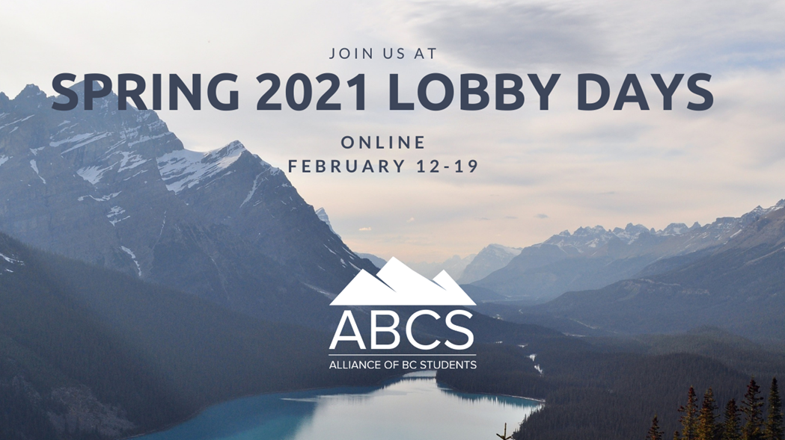

Greetings to the UVic Graduate Students Society,

It is our pleasure to formally invite you and your organization to the Alliance of BC Students’ Spring 2021 Lobby Days conference!

From February 12-19, we will be hosting professional development training and direct lobbying meetings with elected officials and key Ministry stakeholders so that your organization can have a part in shaping post-secondary education in British Columbia for the better. This year, we are excited to be hosting our first online conference in order to best ensure the safety and wellbeing of our delegates and wider communities. We have provided more information under “Conference Format” to explain what an online lobbying conference will look like, as well as the unique opportunities that this presents for our advocacy efforts this year.

**What is Lobby Days?**

As members of the Alliance of BC Students, we’ve been listening to the concerns that your students are facing on campus. Lobby Days is an opportunity for your voice to be heard by the highest levels of the provincial government to ensure that those issues are addressed and changes can be implemented.

Under normal circumstances we gather every Fall in Victoria and schedule a weekend filled with training to ensure that all of our delegates are well prepared to enter meetings with various MLAs and staff. This year, training will primarily take place on February 12, 13 and 14, with some additional training sessions in the two weeks leading up to the conference. While we are unable to meet in person this year, we are committed to providing excellent training sessions and ensuring that students are able to meaningfully connect with elected officials virtually. We will also ensure that everyone has become very familiar with each of our asks during this time. The final asks will be circulated to each participating organization in late January. After this training weekend, groups of 3-4 students will be assigned specific meetings over the course of three days where they will present and discuss the importance of these asks to MLAs and staff.

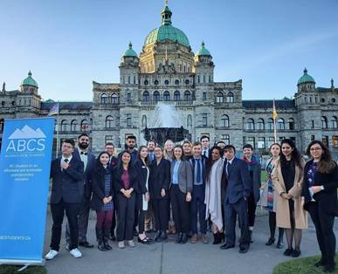.         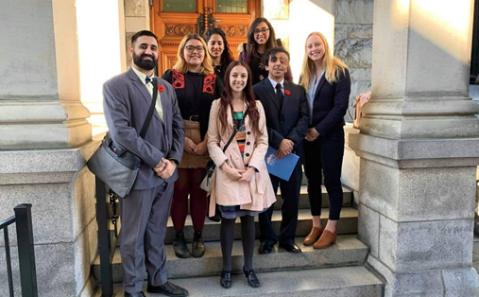

**Conference Delivery Format**

Given the current health and safety guidelines and travel restrictions in BC, we will be holding Lobby Days entirely online this year. While we are very excited to be able to host this conference in person again in the future, we look forward to delivering a safe, informative, and impactful event.

We will be hosting all of our training through Zoom. We are working closely with caucus event organizers and Ministry staff to coordinate our meetings and will keep everyone informed on the format for all meetings as we continue to receive updates.

**Training: February 12-14**

Some additional training sessions will be provided in the weeks leading up to the conference (specific dates and times to be announced)

Attendance at training sessions is mandatory for all delegates who wish to attend any lobby meetings. We require this training in order to provide delegates with the tools they need to succeed in these meetings. If a delegate is unable to attend one of more training sessions we ask that they reach out to Shanti Scarpetta-Lee and Anna-Elaine Rempel right away to figure out a plan to ensure they get the training they require. While we will work with delegates as much as possible to find a solution, if too much training is missed the delegate will be unable to attend meetings.

Delegates will need to complete their individual registration form in order to access our Google Classroom. This online classroom will include research materials, the lobbying document, and additional training resources so that delegates can get a head start on preparing for their meetings.

We will be hosting additional training sessions in the weeks leading up to February 12 in order to spread out this learning and help alleviate “zoom fatigue” during our full training days. Some of these sessions will be recorded for future reference and added to the Google Classroom.

Training sessions will be hosted by a combination of external speakers and experts, and ABCS representatives. Training will cover: lobbying basics, equity, diversity and inclusion, detailed breakdowns of each of our asks, political climate in BC, policy development processes, lobby meeting practice, and more!

**Lobbying: February 16-19**

Each delegate will be assigned around 5 meetings throughout the lobbying portion of the conference. Delegates will be paired in groups of 3-4 for each meeting. While delegates will have some down time in between their meetings, MLA schedules can change very quickly, so we ask that delegates fully book off February at least 16-18 in order to provide flexibility for scheduling. Delegates will receive their meeting schedules on February 12, which will include all necessary information on how to call into your meetings.

Please note that Monday February 15 is Family Day, so no meetings or mandatory training will be held on this day. However, ABCS officers and staff will still be available to answer questions and provide logistical support as necessary for delegates. We encourage delegates to use this day to rest before lobbying begins.

**Registration**

We ask that associations who are not members of the ABCS pay $125 per delegate that they send to attend Lobby Days with us. We have reduced this price from our regular conference registration cost due to the conference being delivered online. Non-member registration fees go towards covering the cost of materials, external speakers, and staff support.

We are also offering a further 25% per delegate discount for graduate student associations to reflect the lower financial capacity of many graduate organizations in comparison to undergraduate societies.

**Undergraduate student society per delegate fee: $125**

**Graduate student society per delegate fee: $93.75**

There are four steps that need to be completed during the registration process:

1. **We require that each association confirm on letterhead that they will be attending.** This is to ensure that the decision to attend Lobby Days is verified by your Board of Directors. It is also helpful if this letter includes how many delegates, and ideally who the delegates will be, we will be expecting. The deadline for your organization to send us this is January 29 by 5pm.
2. **Delegates then must complete their ABCS Lobby Days registration form.** This is important for us to keep in contact with them during the lobbying portion, to do our best to ensure any accessibility needs are met, and to sort them into meetings. The registration form will be circulated once your association has confirmed their attendance on letterhead. The deadline for delegates to complete the registration form is January 30 by 5pm. However, sooner is always preferred.
3. **Delegates must complete the meeting registrations forms provided by the organizing staff of each party**. Delegates who do not fill out these forms on time will not be allowed to attend meetings by caucus staff. These forms will be circulated the week of February 1 and must be completed no later than February 8 at 4pm. However, sooner is always preferred.
4. **Participating associations must pay their delegate fees.** Invoices will be sent shortly after all ABCS Lobby Days registration forms have been received. Final payment is due February 11.

**Schedule**

A detailed schedule will be sent out to delegates once they’ve completed their registration form.

**Contact Information**

If you have any questions, please don’t hesitate to reach out to myself, or our director of research and campaigns, Shanti Scarpetta-Lee, at [campaigns@bcstudents.ca](mailto:campaigns@bcstudents.ca).

For general inquiries, please reach out to our chairperson, Grace Dupasquier at [chair@bcstudents.ca](mailto:chair@bcstudents.ca).

Thank you for your time. We wish your society a successful New Year and we hope you will be able to join us for this incredible advocacy opportunity!

Warm regards,



--

|  |  |
| --- | --- |
| https://abcstudentsdotca.files.wordpress.com/2016/04/download1.png?w=279 | **Anna-Elaine Rempel**  Social Policy Researcher  Pronouns: she/her/hers  **Alliance of British Columbia Students**  (250) 801-8084  [www.bcstudents.ca](http://www.bcstudents.ca) |